
Story

Date | 02 November 2026
Team ID | NA
Project Name | Electric Vehicle Market Performance & Insights
Maximum Marks | 5 Marks

By using stories in Tableau, you can effectively communicate complex data in a way that is both interactive and engaging, making it easier for the audience to follow along and understand the insights. It’s a tool for data storytelling, allowing you to present insights in a cohesive, engaging way that takes viewers through a logical progression of findings or analyses.
In Tableau, Story is a feature that allows you to create a sequence of dashboards, visualizations, and text to present data insights in a cohesive and narrative-driven way. It's like a slideshow within Tableau that guides the audience through a series of data points, helping them understand key insights, trends, or outcomes of your analysis.

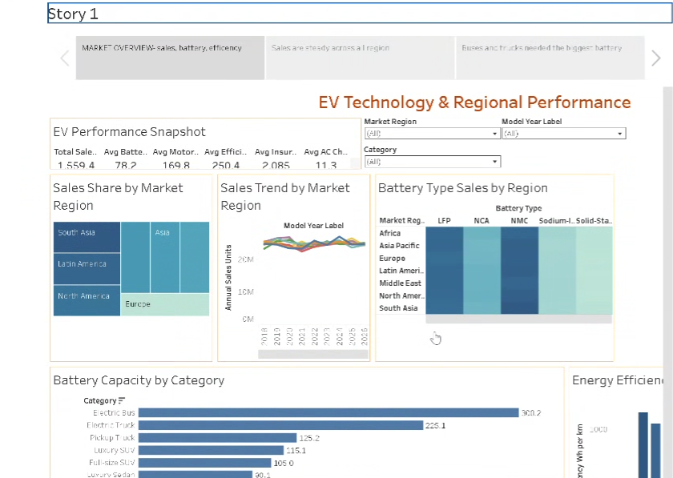

Observations:
- Story point 1 – Market overview: sales, battery, efficiency: The full dashboard with the key figures and region filters.
- Story point 2 – Sales are steady across all regions: Regional sales trends move together, each region near 14% of sales.
- Story point 3 – Buses and trucks need the biggest batteries: Electric Buses (300.2 kWh) and Trucks (225.1 kWh) lead battery capacity.

Activity 2:
Publish Story on Tableau Public and Paste Public link below
https://public.tableau.com/app/profile/riya.sharma8766/viz/ev_riya_final/Story1

